

**Placement Empowerment Program**

***Cloud Computing and DevOps Centre***

Create a script that copies your Git repository to the backup location.

# Name: Sanjay Raj S

Department : IT

# Introduction: Automated Git Repository Backup Script

In software development, version control is crucial for managing code changes, and Git is one of the most widely used tools for this purpose. However, even with Git, maintaining a separate backup of your repository is essential to protect against accidental deletions, data corruption, or server failures.

This guide provides a step-by-step approach to

creating an automated Git repository backup script that runs daily. The script ensures that a mirror copy of your repository is saved to a local backup folder, preserving all commit history and branches. By automating the backup process, developers can safeguard their work without manual intervention, reducing the risk of data loss. The script is designed to be simple yet effective, using standard shell scripting for Linux/macOS and batch scripting for Windows. Additionally, it integrates with Cron Jobs (Linux/macOS) or Task Scheduler (Windows) to run on a scheduled basis.

With this setup, you can ensure that your Git repositories are securely backed up and always

available for recovery in case of emergencies.

Step 1: Choose Your Backup Directory

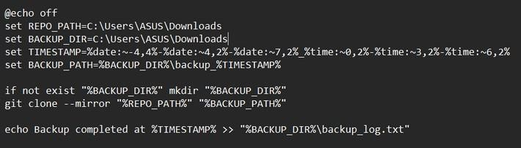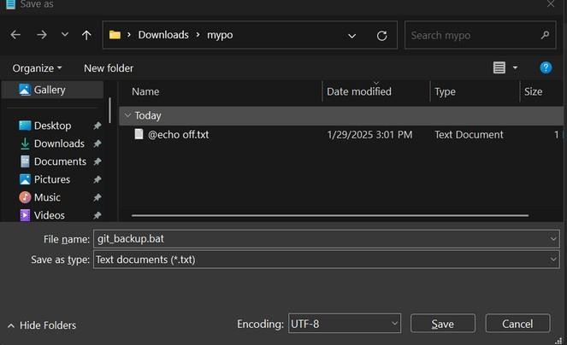

Decide where you want to store your backups. For example:

C:\path\to\backup\ (Windows)

Step 2: Create the Backup Script

Create a script that copies your Git repository to the backup location.

For Windows (Batch Script)

Open Notepad and paste the following:

Save as .bat file

# Windows (Task Scheduler)

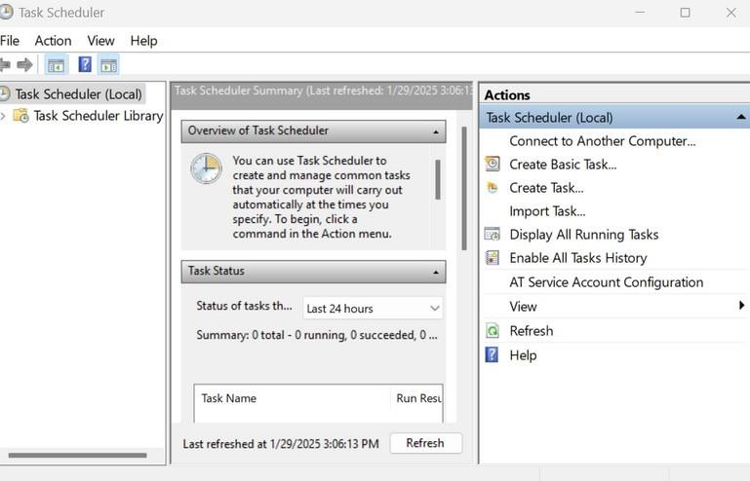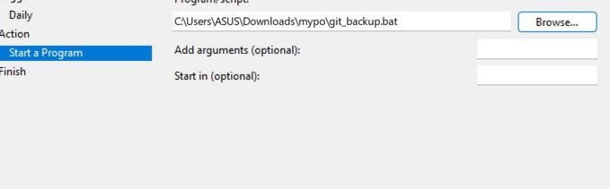

Open Task Scheduler. Click Create Basic Task.

Name it Git Backup and click Next.

Choose Daily, set your preferred time, and click Next.

Choose Start a Program and browse for git_backup.bat.

Click Finish.